# 实验：nginx+keepalived+tomcat负载均衡集群

**ng1 192.168.7.10 vnmnet8**

**ng2 192.168.7.11**

**tomcat1: 192.168.7.12 vmnet8**

**192.168.10.12 vmnet1**

**tomcat2: 192.168.7.13 vmnet8**

**192.168.10.13 vmnet1**

**tomcat3: 192.168.7.14 vmnet8**

**192.168.10.14 vmnet1**

**nfs: 192.168.10.15 vnmnet1**

**tomcat作用：java网站，是开源的技术**

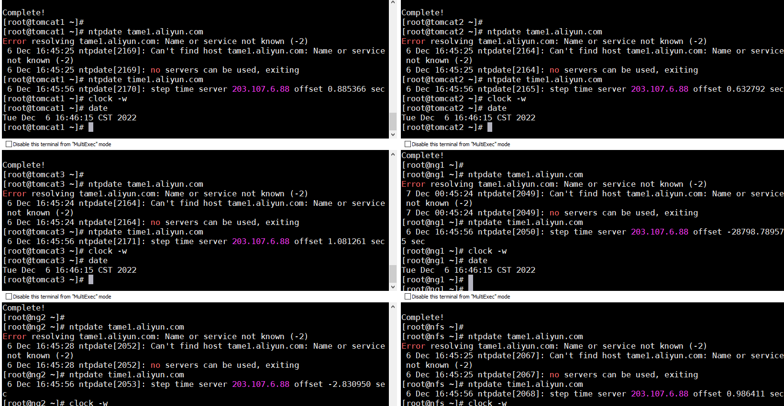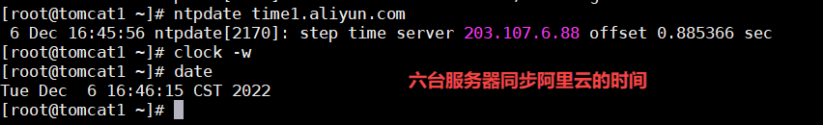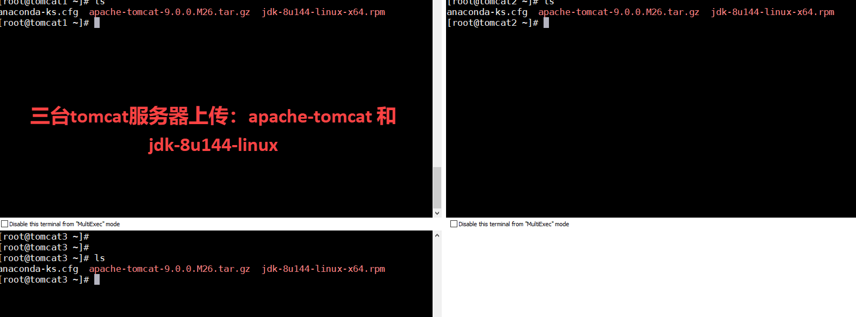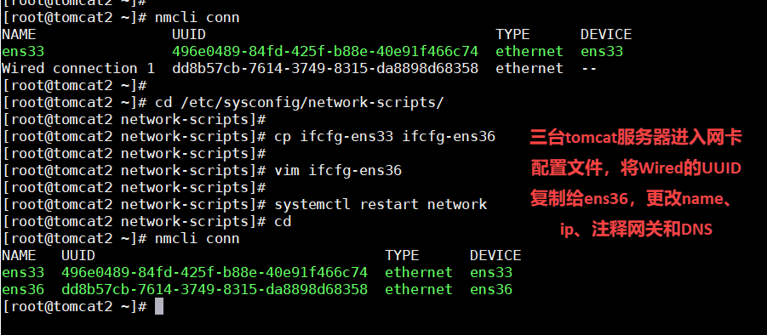

**1.192.168.7.10安装nginx**

**yum install epel-release -y**

**yum install nginx -y**

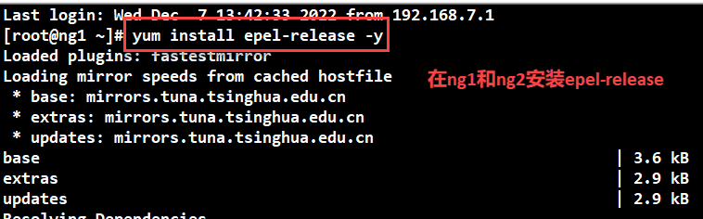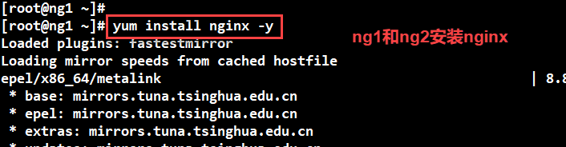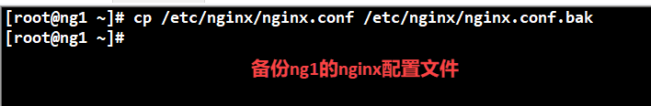

**4.创建nginx反向代理**

**做负载均衡集群12 13 14三台java主机**

**http {**

**log_format main '$remote_addr - $remote_user [$time_local] "$request" '**

**'$status $body_bytes_sent "$http_referer" '**

**'"$http_user_agent" "$http_x_forwarded_for"';**

**access_log /var/log/nginx/access.log main;**

**upstream tomcatserver {**

**server 192.168.7.12:8080;**

**server 192.168.7.13:8080;**

**server 192.168.7.14:8080;**

**}**

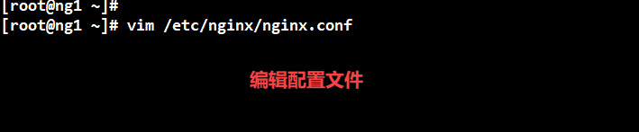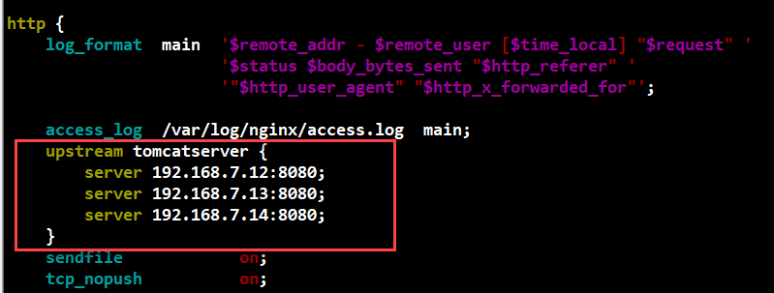

**access_log /var/log/nginx/access.log main;**

**upstream tomcatserver {**

**server 192.168.7.12:8080;**

**server 192.168.7.13:8080;**

**server 192.168.7.14:8080;**

**}**

**反向代理服务**

**[root@ng1 ~]# vim /etc/nginx/conf.d/vhost.conf**

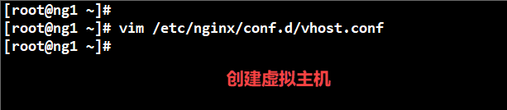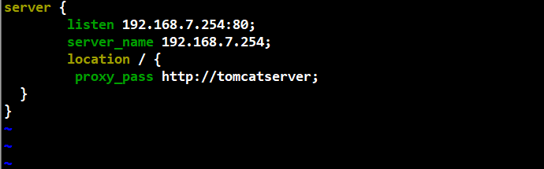

**server {**

**listen 192.168.7.254:80;**

**server_name 192.168.7.254;**

**location / {**

**proxy_pass http://tomcatserver;**

**}**

**}**

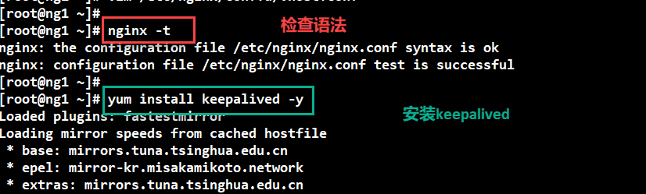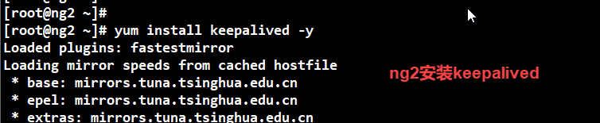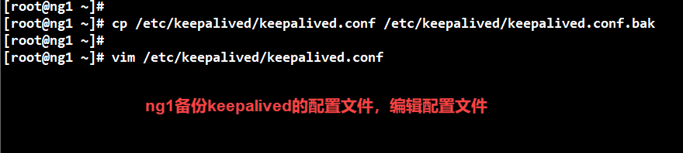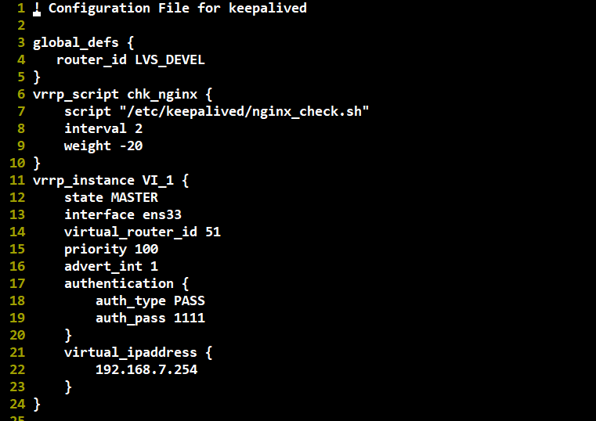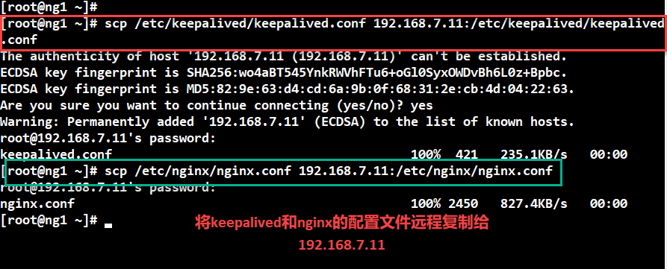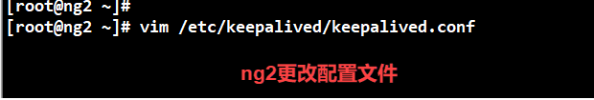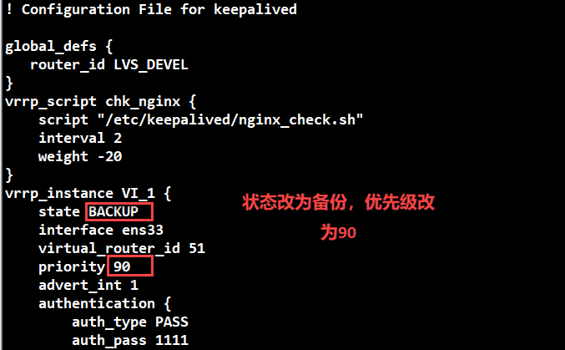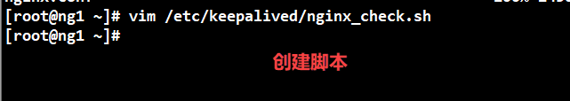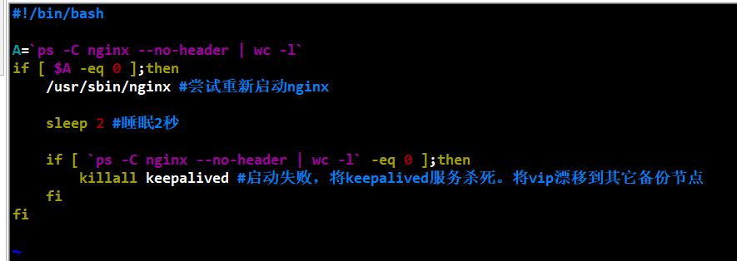

**#!/bin/bash**

**A=`ps -C nginx --no-header | wc -l`**

**if [ $A -eq 0 ];then**

**/usr/sbin/nginx #尝试重新启动nginx**

**sleep 2 #睡眠2秒**

**if [ `ps -C nginx --no-header | wc -l` -eq 0 ];then**

**killall keepalived #启动失败，将keepalived服务杀死。将vip漂移到其它备份节点**

**fi**

**fi**

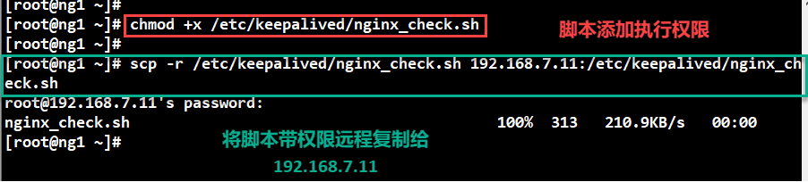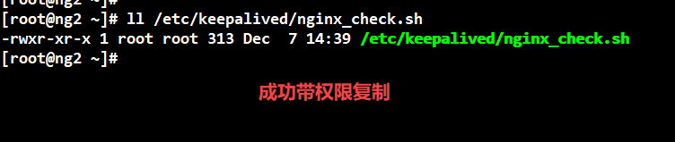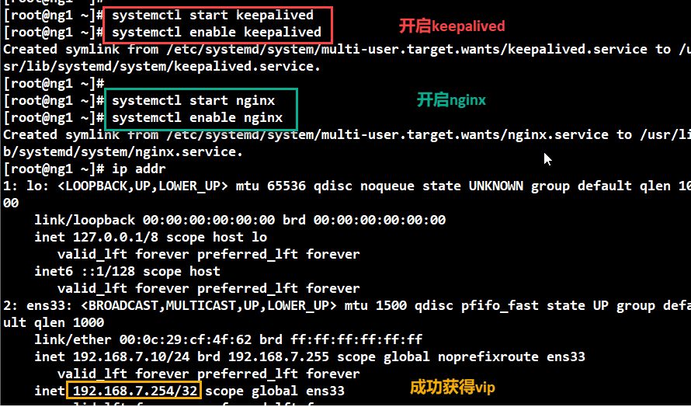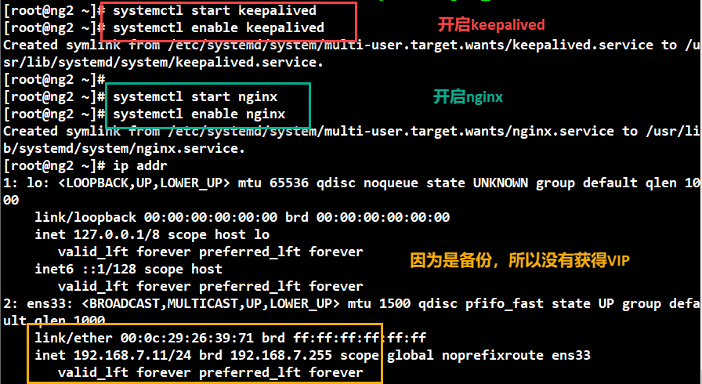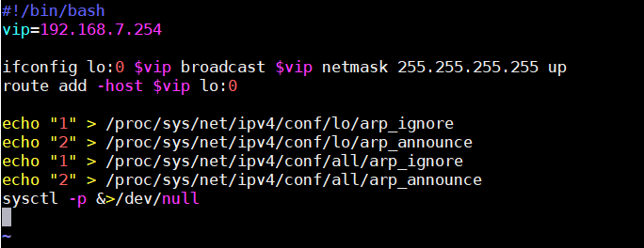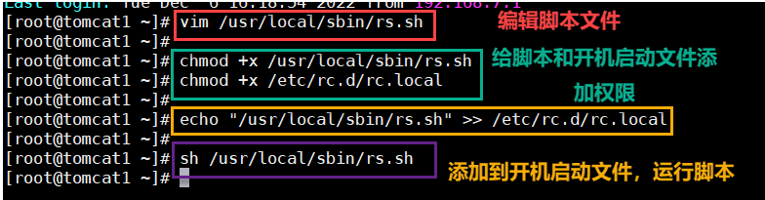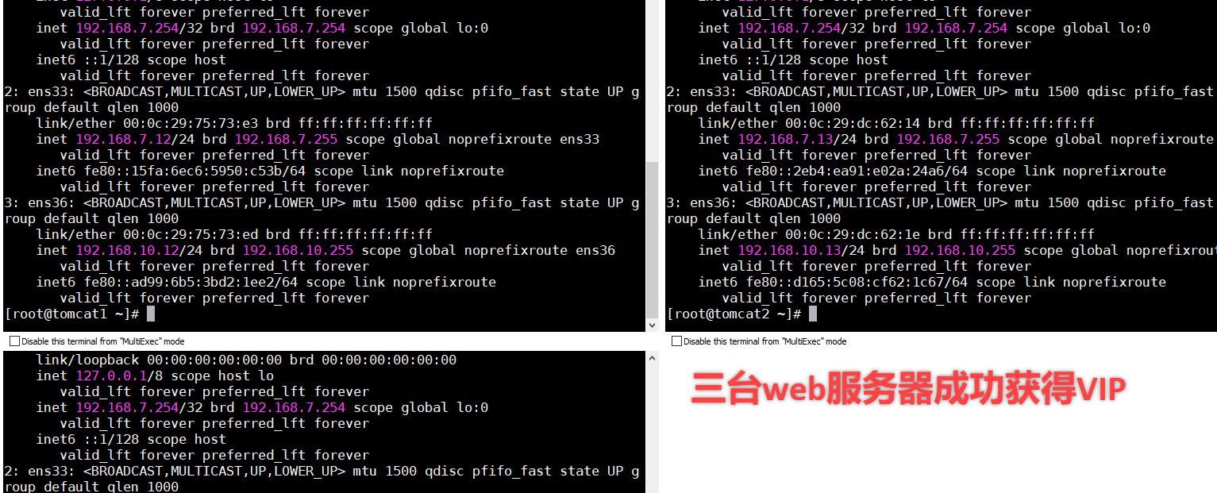

## tomcat1和tomcat2

**1.安装java和配置java环境变量**

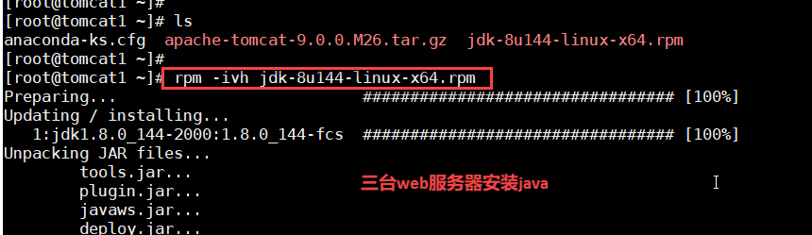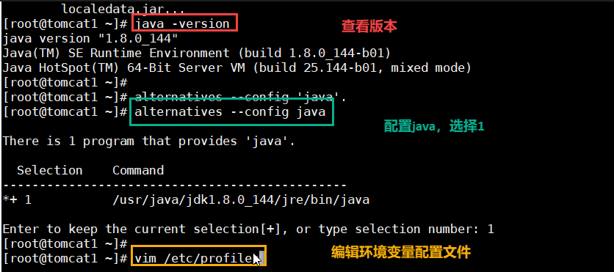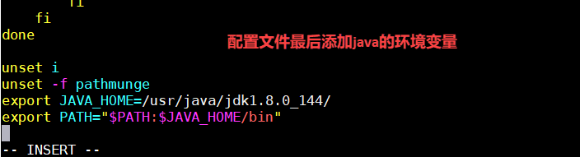

**export JAVA_HOME=/usr/java/jdk1.8.0_144/**

**export PATH="$PATH:$JAVA_HOME/bin"**

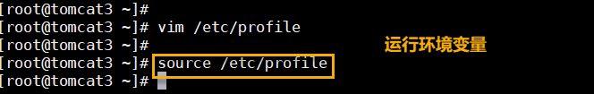

**2.安装tomcat**

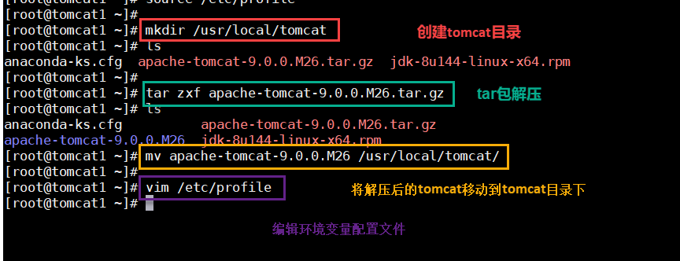

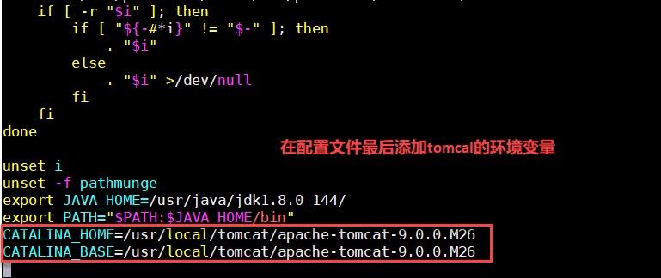

**CATALINA_HOME=/usr/local/tomcat/apache-tomcat-9.0.0.M26**

**CATALINA_BASE=/usr/local/tomcat/apache-tomcat-9.0.0.M26**

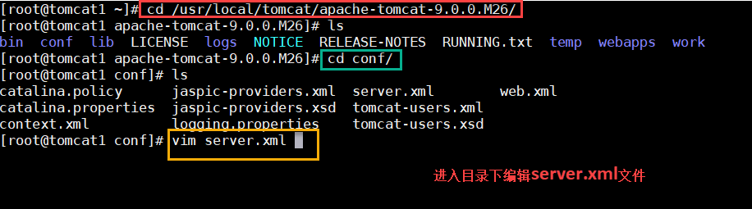

**[root@tomcat2 ~]# vi /usr/local/tomcat/apache-tomcat-9.0.0.M26/conf/server.xml**

**//支持简体中文编码**

**<Connector port="8080" protocol="HTTP/1.1"**

**connectionTimeout="20000"**

**redirectPort="8443" URIEncoding="UTF-8" />**

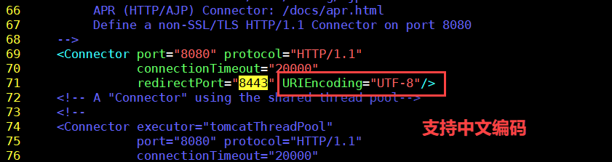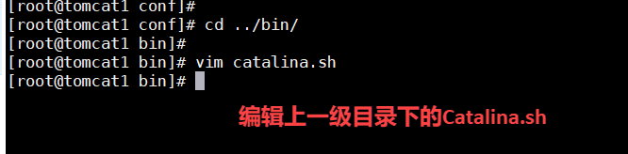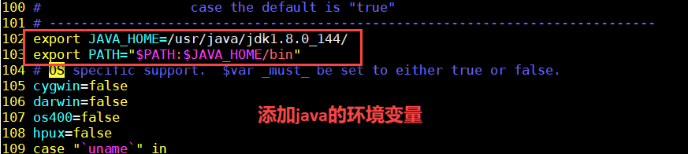

**export JAVA_HOME=/usr/java/jdk1.8.0_144/**

**export PATH="$PATH:$JAVA_HOME/bin"**

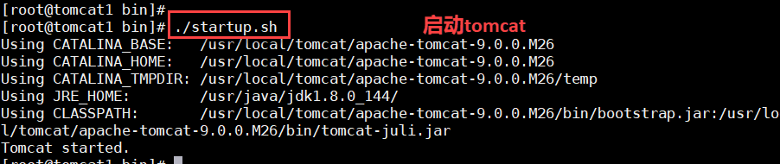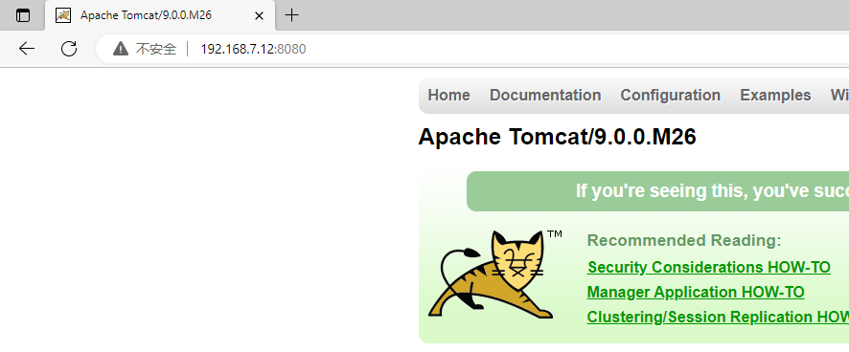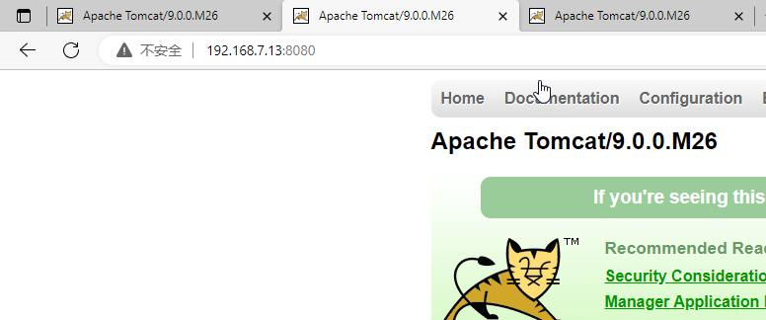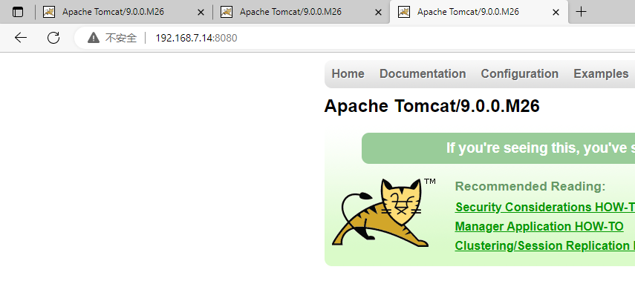

**//创建tomcat启动、关闭和重启的shell脚本**

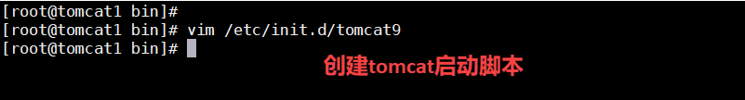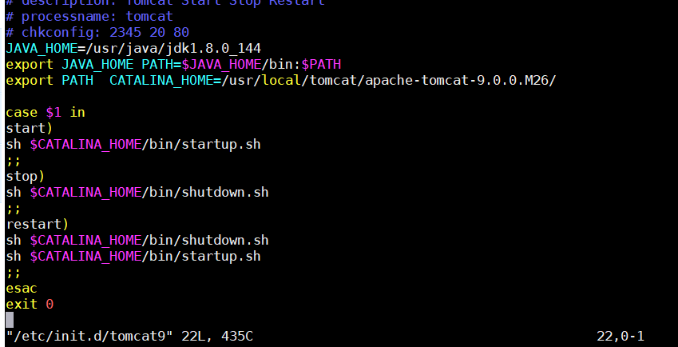

**#!/bin/bash**

**# description: Tomcat Start Stop Restart**

**# processname: tomcat**

**# chkconfig: 2345 20 80**

**JAVA_HOME=/usr/java/jdk1.8.0_144**

**export JAVA_HOME PATH=$JAVA_HOME/bin:$PATH**

**export PATH CATALINA_HOME=/usr/local/tomcat/apache-tomcat-9.0.0.M26/**

**case $1 in**

**start)**

**sh $CATALINA_HOME/bin/startup.sh**

**;;**

**stop)**

**sh $CATALINA_HOME/bin/shutdown.sh**

**;;**

**restart)**

**sh $CATALINA_HOME/bin/shutdown.sh**

**sh $CATALINA_HOME/bin/startup.sh**

**;;**

**esac**

**exit 0**

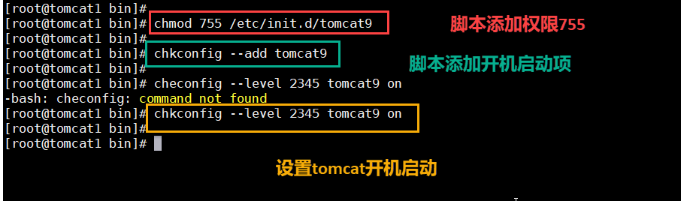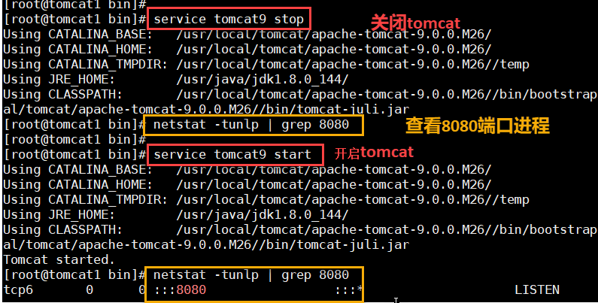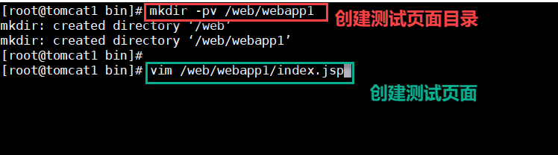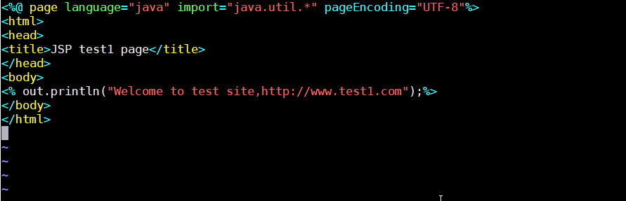

**//java网站的测试页面**

**<%@ page language="java" import="java.util.*" pageEncoding="UTF-8"%>**

**<html>**

**<head>**

**<title>JSP test1 page</title>**

**</head>**

**<body>**

**<% out.println("Welcome to test site,http://www.test1.com");%>**

**</body>**

**</html>**

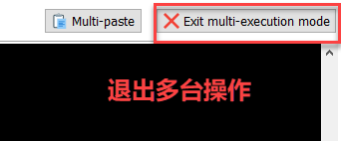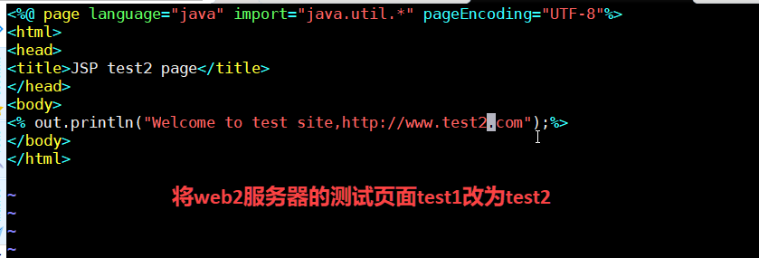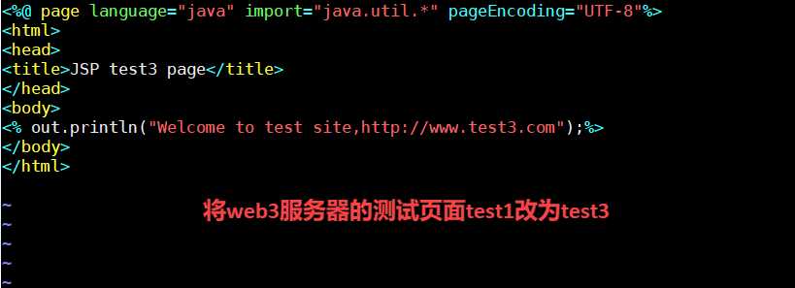

**3.创建java的web站点**

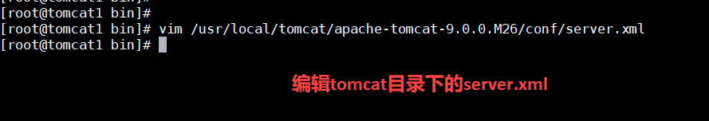

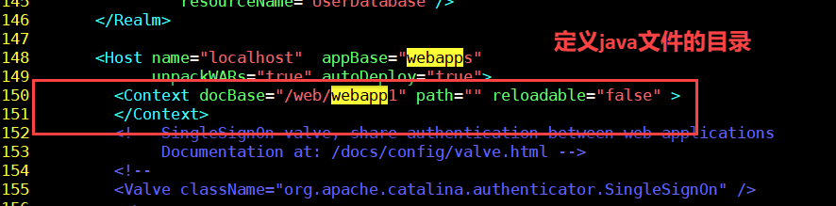

**//定义网站的位置**

**<Context docBase="/web/webapp1" path="" reloadable="false" >**

**</Context>**

